Portfolio Document (__/60)

You need to choose seven photos to put in your digital portfolio. I will grade each caption and photo out of ten points. This will allow you to have one photo that may not be as strong as others.

Focus on the principles: rule of thirds, angle, leading lines, peak of emotion, framing, and center of interest.

I have just put one photo in here to give you an idea of what you need. You need to caption each photo as well. Keep each caption in the present tense and try to name everybody in the photo unless there are seven or more people like this one. If you must have a second sentence use it for background information.

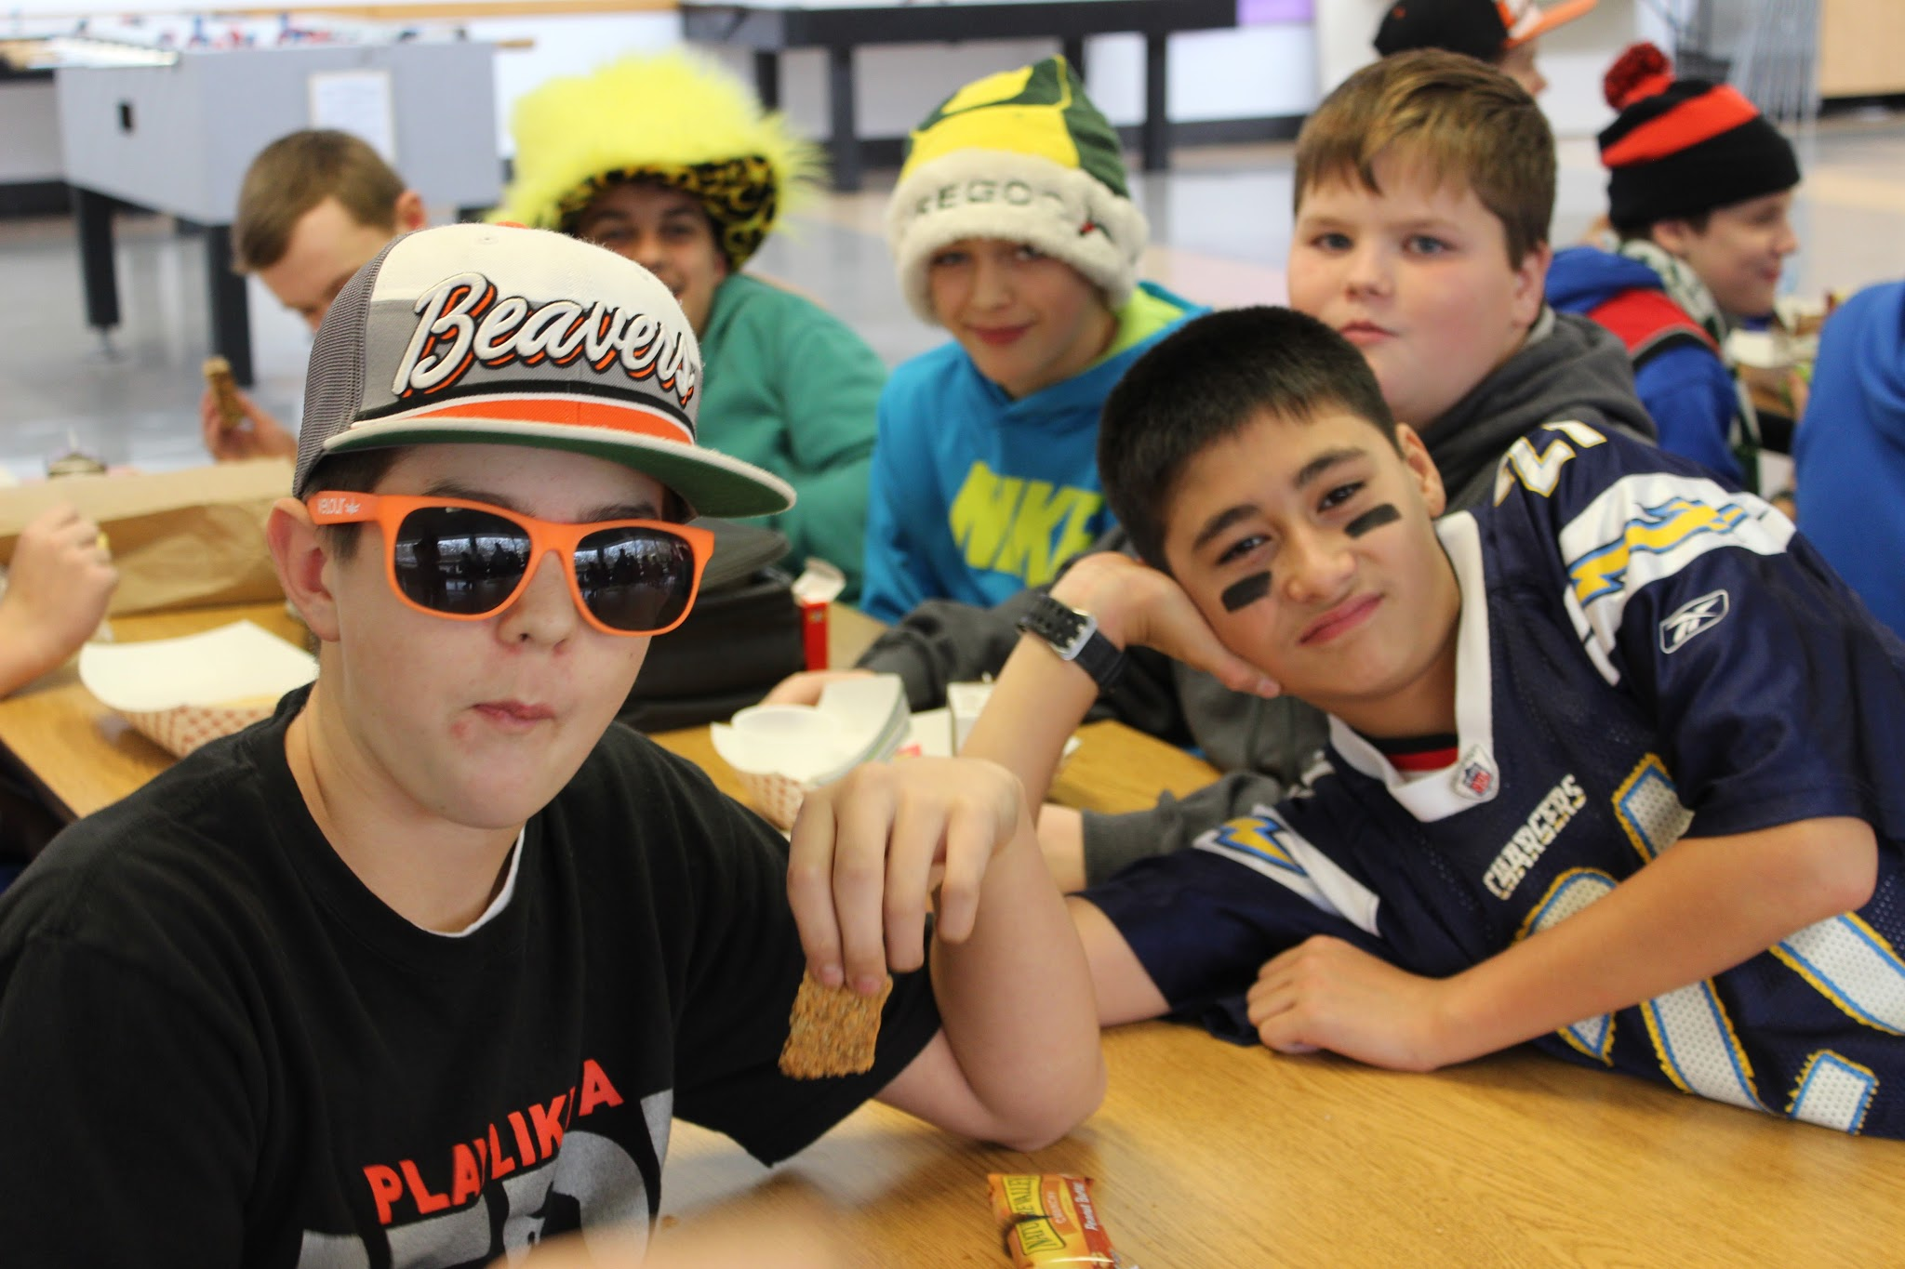
Peak of Emotion
Andru Tran and friends show their school spirit for November’s Rivalry Day. Andru said, “I really enjoy how passionate everyone gets for their teams. It’s cool to see everybody’s passion come out at school.”

Once finished, you must complete this portfolio blurb. I have given you a sentence frame paragraph to help you with your thoughts.

Blurb: I chose these photos, because I think they represent MVMS/our slogan: 7,817 memories: One School. An example of _______________ is ____________. A defining characteristic is ______________________. The key components are _______________. An explanation of ___________ provides insight into _______________.

