Make your kids' holidays bright with new global traditions
ShareTweetPin
It's important that every family creates holiday traditions they take great pride in, but it's equally important to learn about the rich customs and celebrations that take place in different cultures.
Teach your kids about these amazing traditions from around the world. You'll be surprised at how much it enriches your family's own celebration.

Hanukkah in Israel
Jewish people all over the world observe Hanukkah, but perhaps there is not a more brilliant celebration than in Israel. The eight-day holiday, which lands on different dates in December every year, marks the successful Jewish rebellion over the Greeks. The focal point of celebration is the menorah, a branched candelabrum, and most homes have many. Each night, one candle is lit and gifts are often given to children, games are played and food is enjoyed. Children in Israel even get a week off from school.
More: 16 Adorably crafty holiday gifts kids can make themselves

New Year's Eve in Ecuador
In this South American country, a family dresses up a straw man representing the old year. Family members make a will for the straw man that lists all of their faults. At midnight, they burn the straw manin hopes their own faults disappear too.

Kwanzaa in the U.S.
Kwanzaa is a weeklong celebration honoring African-American culture. It was first celebrated in 1966 and is one of the fastest growing holidays. A Kwanzaa celebration often includes singing, drumming and a selection of readings such as the African pledge or parts of African history.
More: The baby names guaranteed to land on Santa's naughty list

Omisoka in Japan
In Japan, Omisoka, or New Year's Eve, is the second most important holiday of the year, following New Year's Day, the start of a new beginning. Japanese families gather for a late dinner around 11 p.m., and at midnight, many make visits to a shrine or temple. In many homes, there is a cast bell that is struck 108 times, symbolizing desires believed to cause human suffering.

Make your kids' holidays bright with new global traditions
ShareTweetPin

Ta Chiu in Hong Kong
Those in Hong Kong pray to the gods and ghosts of their ancestors asking that they will fulfill wishes for the next year. Priests read aloud the names of every person living at the celebration and attach a list of names to a paper horse and set it on fire. The smoke carries the names up to the gods and the living will be remembered.
More: I'm the mean mom who won't give her kids toys this Christmas
Sponsored Content9 Perfect Hostess Gifts You Can Buy on the Way to the Party
I love being invited to parties throughout the holiday season. But, having hosted quite a few seasonal soirees myself, I know how much work goes into putting on a festive fete, so I always try to bring a small gift as my token of appreciation for all of the hostess’s hard work.

Christmas in France
In France, Christmas is called Noel. And though there are many similarities to Christmas in the U.S., you'll find a number of key differences. A figure called Pere Noel, father of Christmas, makes home visits with gifts. On Christmas Eve, children leave their shoes by a fireplace that will be filled with the gifts. In the morning, they awake to find fruits, nuts and small toys. Nearly every home has a Nativity Scene, which serves as the focal point of decoration and celebration, just as the Christmas tree does in U.S. homes.

Christmas in Alaska
Christmas traditions in Alaska are similar to the rest of the Unites States, but there are a few unique differences that make an Alaskan Christmas special. For example, children go caroling with a long pole topped by a colored star. Songs sung in the home often include the Aleut words “Gristuusaaq suu'uq,” which means “Christ is born.” The closing words, “Mnogaya leta,” means, “God grant you many years.” Treats may include cookies, doughnuts, and cake, as well as fish pie called piruk and smoked salmon.

St. Stephen's Day in Ireland
Christmas festivities in Ireland tend to be more religious in nature than about simple fun. Christmas celebrations last from Christmas Eve until January 6th (Epiphany). On the 26th, St. Stephen’s Day, an Irish tradition that is known as the Wren Boys Procession takes place. Children go from door to door singing, holding a stick that is topped by a holly bush and a wren. They ask for money for the “starving wren,” which goes into their pockets. In ancient times, a real wren was killed and fastened to the stick, but today fake wrens are used.

Sviata Vechera in the Ukraine
The Christmas Eve festivities in the Ukraine are known as Sviata Vechera, which means “Holy Supper.” The celebration begins when the first evening star is sighted in the night sky. In farming communities, the household head brings in a sheaf of wheat which symbolizes the wheat crops of Ukraine. It is called “didukh,” which translates to “grandfather spirit.” In homes within the city, a few stalks of wheat may be used to decorate the table.

9 Totally Weird Holiday Traditions Around the World
By Findery
- 160

There are hundreds of holiday traditions around the globe, many of which you’ve probably never heard of — the giant goat made of hay (Sweden), the witch that brings candy (Italy), the burning pile of dirt (Guatemala). But these are the top nine most unexpected, random, weird, awesome holiday traditions from around the world.
The Christmas Log - Catalonia, Spain
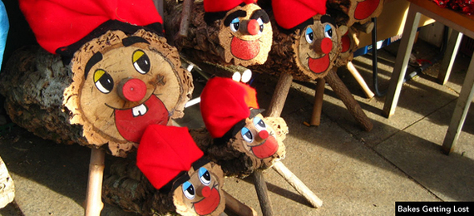
Awww, look at the little Tió de Nadal (Christmas Log). Yes, it’s a log with legs and a face and a little red hat. It may seem like a joke that just caught on, but the tradition hails from old Catalan mythology. The log is introduced in Catalan homes at the Feast of the Immaculate Conception every Dec. 8. Leave food out for your little log each night. He gets hungry you know. And don’t forget a blanket! He might get cold. And when the kids aren’t looking, hide presents under the blanket. You see, the log is hollow, and well, the idea is that it’s pooping out the gifts.
Night of the Radishes - Oaxaca, MX
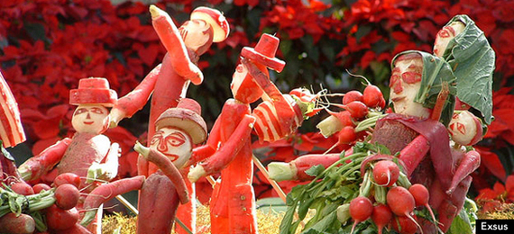
Every Dec. 23, the Mexican state of Oaxaca presents the most impressive display of carved vegetables in the world. The radishes are grown especially for this event, and remain on display through Christmas day. The miniature exhibits depict the Nativity scene and other events from Mexican folklore. Originally, the tradition of radish carving was done by shopkeepers who wanted to entice people into their stores. Today, it’s a three-day festival.
SantaCon - Big Cities Worldwide
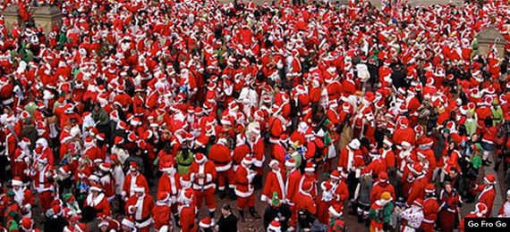
What began as a nonsensical gathering of San Franciscans dressed as Santa Claus, has become a worldwide pub crawl. Celebrating its 20th anniversary in 2014, the official website describes it as “a conventions of santas - groups of men and women dressed as Santa.” That’s all it takes? Well, as specified in the very important guidelines, one cannot merely show up in a Santa hat. And one must address every single participant as “Santa.” Alrighty then.
Spider Webs for Good Luck - Ukraine
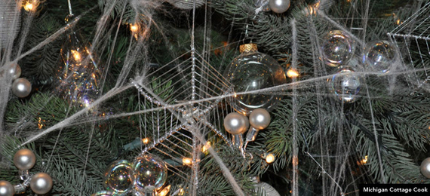
The Ukrainian tradition of adding spider webs to the Christmas tree is odd, until you learn about the legend. In a nutshell: a poor widow lived with her children in a cold, damp hut. Her children had their sights set on a young Evergreen tree growing outside as their future Christmas tree. But they had nothing to decorate the tree. The woman cried herself to sleep that night, but the household spiders took note of her despair, and covered the tree in their intricate webs. In the morning, the sun hit the tree, which shimmered in silver and gold thread. From that day on, the widow never wanted for anything again.
Hide All Brooms - Norway
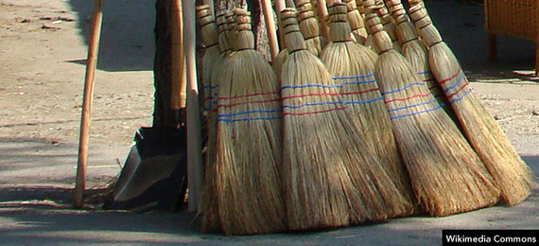
A vestige of ancient pagan days, Norwegians go to the trouble of hiding all brooms on Christmas Eve. And sometimes the menfolk even take out their guns and fire a warning shot into the air. According to legend, witches and other evil spirits come out on that night each year. And you know what witches want...brooms.
KFC - Japan
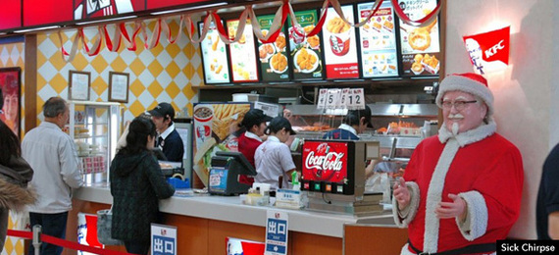
Ok, we kinda get this one. Fried chicken on Christmas Eve sounds like a good idea. Sure, but why KFC? Every establishment has a long line trailing out the door. Christmas isn’t a national holiday in Japan, so it must be something about the “Americanness” of the meal. That and good marketing that goes back to the 1970s. The tradition holds strong. There’s even a Smithsonian article about it.
Roller Skating to Mass En Masse - Venezuela
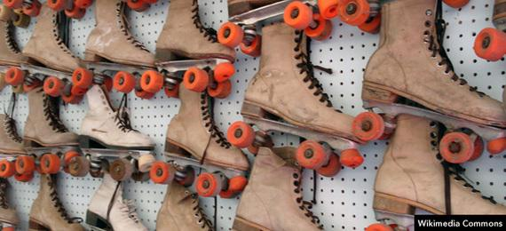
Now here’s a fun Christmas tradition. Besides waking to firecrackers in the wee hours of the morning, residents of the Venezuelan city of Caracas get up, pull out their roller skates, and take off for mass. Many streets are closed to traffic and whole families wheel their way into the church pews. To hear the sound of skates in those sacred spaces!
Caroling with a Dead Horse - Wales
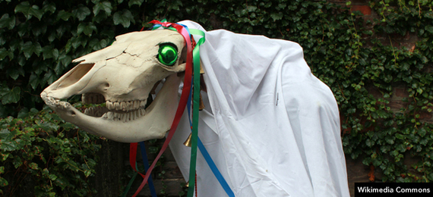
On no particular day or time, from Christmas to late January, Mari Lwyd is a ritual of old, meant to bring good luck. One person dresses up as a horse, using an actual horse skull, and is accompanied by a group of people. Together they go from house to house and sing in the hopes that they will be rewarded with food and drink. This is not as foreign a tradition you might think. It is referred to in the Christmas carol “Here We Come A-wassailing.”
Krampus - Austria, Germany, Hungary
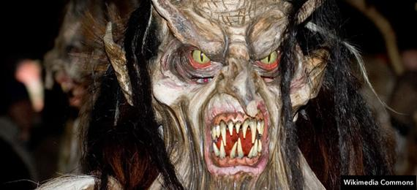
For the good children, there is Santa Claus. For the bad, there is Krampus, a beast-like creature who shows up in order to punish the ill-behaved. Just the sight of him is punishing indeed! Krampus has roots in Germanic folklore. Today, young people dress up as Krampus and roam the streets in Austria, Romania, Bavaria, and other Balkan countries to frighten young children. Merry Christmas, everyone!

