CORNELL NOTES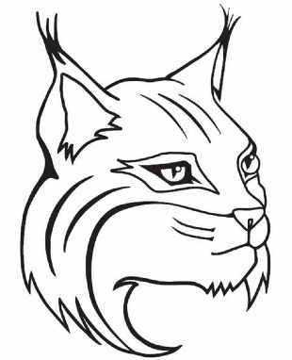 | TOPIC/OBJECTIVE:  Core Concepts 3.1 Culture | NAME:_______________________________________________  CLASS/PERIOD:____________________________________  DATE:________________________________________________
ESSENTIAL QUESTION:
What is culture?
QUESTIONS:  What are the elements that make up a culture? | NOTES: Page ______  All people have the same basic _______________ and ____________such as ________________________________________.  But different cultures respond in different ways. Culture is the _______________________, ____________________,  _______________________________, and _____________________ of a particular ________________________or group of _______________________________.
What is a cultural trait? | A cultural __________________is an ________________________or ___________________of doing things that is
 | _____________________________in a certain culture. Cultural traits include _______________________, ____________,
 | ____________________, _____________________, _____________________, _______________________, and many other
 | ______________________________.
 | Children learn cultural traits from the mass media and from organizations such as _________________,
 | ____________________________, and ______________________________.
What are norms? | Common cultural traits are called _______________________. A norm is a _________________________
 | that is considered ________________in a society.
 | Some cultural traits remain ________________over many years. But culture can change over time as people
 | adopt _____________________cultural traits. For example, __________________________________________________________
 | ________________________________________________________________________.
How does environment affect culture? | The environment can affect culture. For example, the environment influences how people _______________
 | and how they ________________________. Humans can also shape their environment by creating ______________
 | __________________________. The cultural landscape of a place reflects how its people meet their basic needs
 | for _________________________, _____________________, and _____________________________.
How are Culture and Geography connected? | Culture Geography
 | In a specific culture _____________________, people share ___________________such as ______________________________.
 | Culture regions are often ________________________ from political units. Occasionally, a cultural region may
 | Cover an entire ______________________. In Japan, for example, everyone speaks the same _____________________
 | Eats the same _______________________, and follows the same _______________________________.
 | Cultural regions can also ______________________beyond political boundaries. For example, many of the
People who live in Southwest ______________ and norther ________________________are _________________________.

They practice the religion of _______________________________. They also share ______________________________

such as _______________________________________________________________________________________________________.

This region of _______________________________culture covers __________________________countries.

SUMMARY | In this lesson I learned _________________________________________________________________________________________.
 | A key detail from the text is ___________________________________________________________________________________.
 | Another important detail from the text is that culture and geography _____________________________________.
As a result of learning about __________________________________ I now understand that ____________________.

