CORNELL NOTES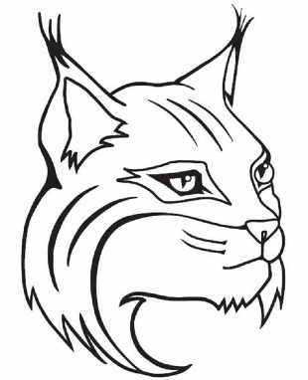 | TOPIC/OBJECTIVE:  Core Concepts 1.3 Archeology and Other Sources | NAME:_______________________________________________  CLASS/PERIOD:____________________________________  DATE:________________________________________________
ESSENTIAL QUESTION:
How can Archaeology and other historical sources offer clues to what life was like in the distant past.
QUESTIONS:  What is Archeology? | NOTES: Page 8-9  Over time, much of the ___________________world has ___________________________.
 | Large cities have _______________________into ______________________. Buildings are __________________under
 | ___________________________and sand or covered by thick forests.
 | Artifacts show what life was like in ____________________times and are ___________________or _______________.
 | _________________________is the ____________________________study of ancient _________________________ through
 | the ____________________________of artifacts and other evidence.
What is Anthropology? | Anthropology helps _____________________________understand the past. _________________________is the
 | Study of ______________________________ all aspects, especially _____________________and ______________________.
How do archaeology and anthropology help us understand the past? | Archeologists Anthropologist  are study search for explore are study seek to understand try to determine find clues to
SUMMARY | In this lesson I learned _________________________________________________________________________________________.
 | A key detail from the text is ___________________________________________________________________________________.
 | Another important detail from the text is that _____________________________________________________________.
 | As a result of learning about __________________________________ I now understand that ____________________.

